Title of Your Contribution
Letter(s) of suiting Topic(s) (A, B,…K):
Intended Presentation (poster: P, oral: O):
I. M. Author¹⁾, U. R. Too²⁾, Y. R. Ntyou²⁾
¹⁾ Department, Institution/Company, Town, State/Country
²⁾ Different Department, Different Institution/Company, Town, State/Country
Email address of corresponding author
Summary: Clearly state what is new in this first paragraph. The degree of novelty and clearness will be some of the major evaluation criteria in the review process. Relate your work to what has been already done. This section should describe your major achievements and represent a summary and conclusions of your contribution in a nutshell. Please do not submit papers that have already been published elsewhere. A maximum of 200 words should be appropriate for this section. Indicate which Session Topic your paper matches and whether you prefer to do an Oral or a Poster Presentation.
Keywords: Provide a maximum of five keywords here

Motivation
Here is some space to describe the background of your work. Cite one or two typical references using brackets in the style as provided at the end of this document [1]. You may refer to the figures if appropriate to illustrate basic structures, device designs etc. (Fig. 1) not forgetting to describe what the reader should recognize in this figure.
Fig. 1: One-column figure example. Briefly characterize here the main idea of the figure.

Sample Results
It is mandatory to present sample results in your abstract. Illustrate your approach and latest results by referring to figures as demonstrated here (Fig. 2 and Fig. 3). Clearly distinguish between already obtained results and those you might expect during the final steps of your work and eventually include in the full-length conference paper.
 | 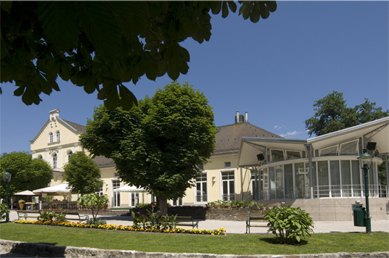
Fig. 2: On-Board materials test assembly Demonstrators (Example of two figures simply placed in an invisible two-column table). | Fig. 3: You can use automatic fitting by first preparing this table and inserting your graphic e.g. from the clip board into the respective table field.
If you want to include photographs or other bitmaps please proof that the resolution is appropriate for the final size (e.g. 200 to 300 dpi in the final size) and all labeling is readable.
Underline the presenting author and make sure that the email address of the corresponding author is provided as well.
Important: Please note that the same high quality level is expected from both types of paper – oral and poster paper. Due to the fact that the conference will have no parallel oral sessions the regular contribution is a poster paper. However, some papers which from their subject address a broader auditory will be selected for the oral sessions. Placement is at the Technical Program Chair's discretion.
Abstracts will be reviewed for technical merit, content, and clearness by an international Technical Program Committee. All accepted abstracts will be included in a Book of Abstract and published independently of the conference papers and will be available at the conference. The accepted full-length conference papers are planned to be published by the online library IEEE Xplore.
If you don’t use this MS-Word template, please adhere to the style as closely as possible. In particular, do not change the page type area (paper format: DIN A4 = 297 x 210 mm. Upper and bottom margin: 25 mm, outer margin: 25 mm, inner margin: 20 mm) and be sure your abstract does not exceed two pages. Otherwise you risk cutting. Please submit your abstract as Word document (.doc) (if available) and as PDF, and the completed “ISSE2013_Abstract_Registration.xls” to: → isse2013@uab.ro
with the e-mail subject:
- ISSE 2013-Abstract, your last name

Acknowledgement
Place an acknowledgement here if suitable.

References
- I. Knoweverything, "Title of important work", J. Appl. Phys., vol. 38, no. 1, pp. 33-44, 2013.
- http://isse2013.uab.ro [23.10.2011].

